**Presentation Material for** **Research and Community Service Announcement of the Ministry of Research and Technology / BRIN in 2021**

By: **Chalid Luneto**. February 23, 2021. 12:19:39

**Research** Presentation Material: Live Streaming February 18, 2021

1. Materials of the Minister of Research and Technology/BRIN

2. Deputy for Research and Development Enforcement

**Services** Presentation Material: Live Streaming February 23, 2021

1. Materials of the Minister of Research and Technology/BRIN

2. Deputy for Research and Development Enforcement

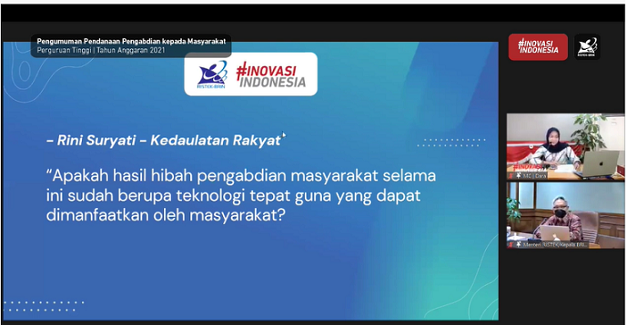

Research and Community Service Funds Announcement

Universities of the fiscal year of 2021

Innovation of Indonesia

* Rini Suryati – People's Sovereignty’

“Did the results of community service grants so far have been the form of appropriate technology that can be utilized by the community?